19CS104T – INTRODUCTION TO INFORMATION AND COMPUTING TECHNOLOGY

UNIT – I

WWW and INTERNET SERVERS
Syllabus: Internet Application-Ecommerce-Business Information Systems, Social Impact of Information Technology-Browser fundamentals - Authoring tools - Types of servers: Application Server - Web Server - Database Server

I Internet Application
- TheWorld-WideWeb(WWW)
- Electronic Mail(E Mail)
- File Transfer Protocol(FTP)
- Search Engine
- Chatting
- Video Conferencing
- E-Commerce

World Wide Web ( WWW)
- The World Wide Web is a system of interlinked hypertext documents accessed via the Internet
- With web browser, one can view web pages that may contain text, images, videos, and other multimedia and navigate between them via hyperlinks.
- It uses a protocol called HTTP Hypertext Transfer Protocol
- HTTP defines how messages are formatted and transmitted, and what actions Web servers and browsers should take in response to various commands.
- A Uniform Resource Locator, or URL is the address of a document on the WWW.
- The elements in a URL:Protocol://server's address/filename
  - Example: http://www.google.com/index.html
- Types of website:
  - Static–A static website is one that has web pages stored on the server in the format that is sent to a client web browser. It is primarily coded in Hypertext Markup Language (HTML)
  - Dynamic–A dynamic website is one that changes or customizes itself frequently and automatically, based on certain criteria.

Electronic Mail (Email)
- The transmission of messages over communications networks.
- It is a fast and efficient way to communicate with friends or colleagues.
- Communicate with one person at a time or thousands; can receive and send files and other information
- Basic email functions:
–send and receive mail messages
–save messages in a file
–print mail messages
–reply to mail messages
–attach a file to a mail message

Web-based mail
- Is an e-mail service intended to be primarily accessed via a web browser?
- Very popular web mail providers:–Gmail–Yahoo!Mail–Hotmail
- Web mail is popular as it allows you to send or receive e-mail from anywhere.

File Transfer Protocol (FTP)
- The protocol for exchanging files over the Internet.
- Used for moving files between two hosts on a TCP/IP network.
- FTP is most commonly used to download a file from a server using the Internet or to upload a file to a server.
- To do FTP, a user invokes one of two commands:
    - get-the command for transferring a file from another server to another computer.
    - put-the command for moving a file from one computer to another one.

Search Engine
- A search engine is designed to search for information on the internet.
- Search engine presents the search results in the form of a search results list.
- The search results can be web pages, images, videos, and other type of files.
- Example:–Google–Bing

Chatting
- Chatting is the other method for Internet conversation.
- It enables people connected anywhere on the Internet to join in live discussions.
- Chat sessions allow many users to join in the same free-form conversation, usually centered around a discussion topic.
Examples:
•MSNMessenger
•YahooMessenger
•IRC
•Pidgin

Video Conferencing
- A video conference or video conference is a set of interactive telecommunication technologies which allow two or more locations to interact via two-way video and audio transmissions simultaneously.
- The other components required for a videoconferencing system include:
  - Video input and output
  - Audio input and output
  - Data transfer
  - Computer

E-Commerce
- Electronic commerce or E-Commerce consists of the buying and selling of products or services over electronic systems such as the Internet and other computer networks.
- It includes the entire online process of developing, marketing, selling, delivering, servicing and paying for products and services.
- Some common applications related to electronic commerce are the following:
- Domestic and international payment systems
- Group buying
- Automated online assistants
- Online shopping and order tracking
- Online banking
- Shopping cart software
- Electronic tickets

II E-commerce
- Introduction
In e-commerce, all transactions are carried out electronically using the network connection. Some of the e-commerce applications are:
- Banks connected to their customers providing services such as deposits, payments and account status information.
- Railways/airlines/cinema theatres permitting booking tickets online
- Filing tax returns with government agencies on-line
- Electronic publishing to promote marketing, advertising, sales and customer support
- Web-based education materials which allows students to learn anytime and anywhere.
- Business to Consumer E-commerce (B2C model)
In B2C model, a business website is a place where all the transactions take place directly between a business organization and a consumer.
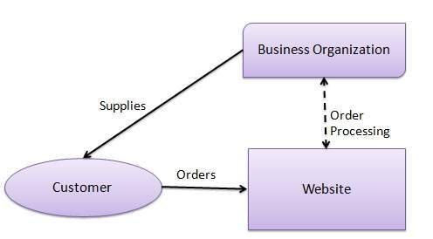
In the B2C model, a consumer goes to the website, selects a catalog, orders the catalog, and an email is sent to the business organization. After receiving the order, goods are dispatched to the customer. Following are the key features of the B2C model −
- Heavy advertising required to attract customers.
- High investments in terms of hardware/software.
- Support or good customer care service.

Consumer Shopping Procedure
Following are the steps used in B2C e-commerce −
A consumer −
- Determines the requirement.
- Searches available items on the website meeting the requirement.
- Compares similar items for price, delivery date or any other terms.
- Places the order.
- Pays the bill.
- Receives the delivered item and review/inspect them.
- Consults the vendor to get after service support or returns the product if not satisfied with the delivered product.
- Business to Business E-Commerce
A website following the B2B business model sells its products to an intermediate buyer who then sells the products to the final customer. As an example, a wholesaler places an order from a company's website and after receiving the consignment, it sells the end product to the final customer who comes to buy the product at the wholesaler's retail outlet.
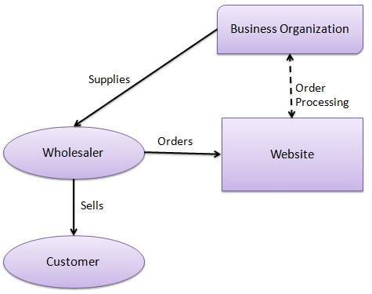
B2B identifies both the seller as well as the buyer as business entities. B2B covers a large number of applications, which enables business to form relationships with their distributors, re-sellers, suppliers, etc. Following are the leading items in B2B e-Commerce. Ex: Electronics, Shipping and Warehousing, Motor Vehicles, Petrochemicals, Paper, Office products, Food, Agriculture etc.

Architectural Models
Following are the architectural models in B2B e-commerce −
- Supplier Oriented marketplace − In this type of model, a common marketplace provided by supplier is used by both individual customers as well as business users. A supplier offers e-stores for sales promotion.
- Buyer Oriented marketplace − In this type of model, buyer has his/her own market place or e-market. He invites suppliers to bid on product's catalog. A Buyer company opens a bidding site.
- Intermediary Oriented marketplace − In this type of model, an intermediary company runs a market place where business buyers and sellers can transact with each other.
- Consumer to Consumer E-Commerce
C2C e-commerce is the one used by two individuals who want to sell/buy items. Such items are usually second-hand things, antiques etc. The seller posts the description of the item and the expected price on a web site maintained by a facilitating company. A website called e-Bay pioneered this idea in USA, and usually acts as an intermediary.
- Advantages and Disadvantages
Advantages:
- Businesses using the World Wide Web have an international presence and can operate (24 × 7) at low cost.
- In several cases, middle men can be eliminated with direct business-to-business contact.
- All transactions are very fast as electronic communication is almost instantaneous.
- Delay in fund transfer is minimal.
Disadvantages:
- Issues of security.
- Business models can be quickly copied by competitors.
- E-Commerce System Architecture
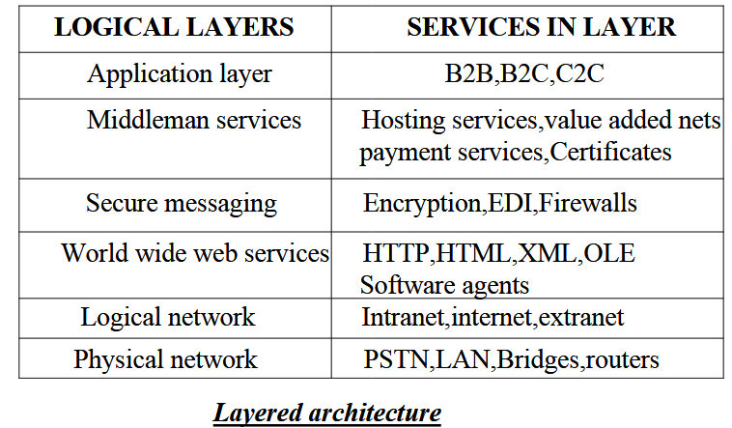
- Digital Signature
A digital signature is a mathematical scheme for verifying the authenticity of digital messages or documents.
REQUIREMENTS
- Needed to ensure that a message received from say "A" is indeed from him
- Signature should be tied to the message sent by "A"
SENDING STEP
- Sender sends key using RSA system
- Sender sends plain text "M" using DES
- Receiver decrypts cipher text using DES and the key received from sender call it "MR"
- Sender hashes plain text "M' using a hashing function - let the hashed text be "H"
- Hashed text "H" encrypted by sender using his Private Key
- DS is his signature as H encrypted with his private key
- DS decrypted by receiver using sender's Public key and obtains "H"
Authentication step
- Receiver hashes “MR" using hash functions and gets“HR"
- Receiver compares “H" with “HR"
- If they match then it is a signed authenticated plain text
- TM is signed as sender has encrypted the hashed text using his private key which he only knows.
- If H=(MR)(HASHED) = HR where MR is the received message then MR must have been sent by sender. He cannot repudiate.

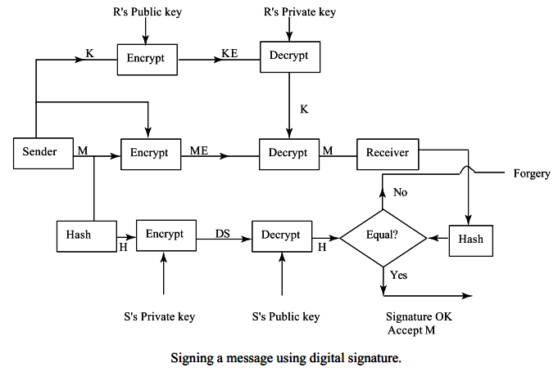
- Payment schemes in e-commerce
Payment is an important component in e-commerce.
- Payment using Credit cards
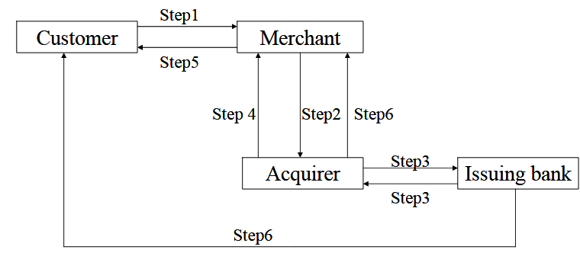
In manual credit card transactions, the transaction is validated using the physical card and the customer’s signature on the card. In e-commerce there is no physical contact between the merchant and the customer making it impossible to verify a physical signature. Also it is necessary for the merchant to verify the genuineness of the customer and for the customer to be assured that he is not dealing with a fake merchant. Thus a customer would be reluctant to reveal his credit card number and details using the internet as the merchant may be a fake or the number may be stolen by eavesdroppers on the internet. Further, if the merchant is careless, a hacker may access the merchant’s data base and steal credit card numbers. There have been cases reported in the press of credit card numbers being stolen by hackers as well as by disgruntled employees of the merchants themselves. Thus, a protocol is required in which the credit card number is not revealed to a merchant but only to the acquirer who authorizes sale based on the credit card validity and available credit. In addition to this, the acquirer and the bank need not know what was bought by a customer (to protect the privacy of customers). They need to know only the bill amount.
- Secure Electronic Transaction (SET) protocol
A protocol called Secure Electronic Transaction (SET) has been standardized for credit card payments by major credit card companies such as Visa and MasterCard in the USA. To use the SET protocol for credit card transactions the following are assumed.
(1) Public key encryption systems (such as RSA) are used by both customers and merchants. Thus each of the parties involved in e-commerce transactions have a pair of keys: a private and a public key.
(2) All parties have their public keys certified by a certification authority and these certificates accompany requests for service sent by them. This is to assure both customers and merchants that they are dealing with genuine parties.
(3) A standard hashing algorithm is used to create message digests for digitally signing purchase orders.
- Dual signature scheme
SET protocol depends on an innovation called dual signature whose main purpose is to give to a merchant the purchase order and amount only (without revealing the credit card number) and give the credit card number and the amount to be paid (without revealing the purchase order details) to the acquirer.
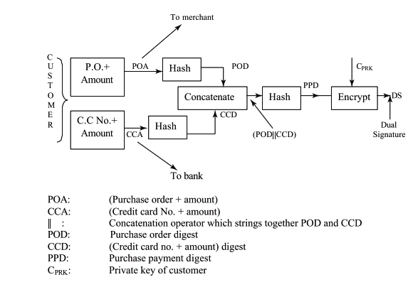
- Electronic clearing service in e-commerce
ECS is an electronic mode of funds transfer from one bank account to another. It can be used by institutions for making payments such as distribution of dividend interest, salary, pension, among others. It can also be used to pay bills and other charges such as telephone, electricity, water or for making equated monthly installments payments on loans as well as SIP investments. ECS can be used for both credit and debit purposes.
How do you avail of an ECS scheme?
You need to inform your bank and provide a mandate that authorizes the institution, who can then debit or credit the payments through the bank. The mandate contains details of your bank branch and account particulars. It is the responsibility of the institution to communicate the details of the amount being credited or debited to their account, indicating the date of credit and other relative particulars of the payment. You will know the money has been debited from your account through mobile alerts or messages from the bank. The ECS user can set the maximum amount one can debit from the account, specify the purpose of debit, as well as set a validity period for every mandate given.
- Cash transactions using e-wallet
E-wallet is a type of pre-paid account in which a user can store his/her money for any future online transaction. An E-wallet is protected with a password. With the help of an E-wallet, one can make payments for groceries, online purchases, and flight tickets, among others.
E-wallet has mainly two components, software and information. The software component stores personal information and provides security and encryption of the data. The information component is a database of details provided by the user which includes their name, shipping address, payment method, amount to be paid, credit or debit card details, etc.
For setting up an E-wallet account, the user needs to install the software on his/her device, and enter the relevant information required. After shopping online, the E-wallet automatically fills in the user’s information on the payment form. To activate the E-wallet, the user needs to enter his password. Once the online payment is made, the consumer is not required to fill the order form on any other website as the information gets stored in the database and is updated automatically.
- Electronic Data Interchange
Electronic Data Interchange (EDI) is the electronic interchange of business information using a standardized format; a process which allows one company to send information to another company electronically rather than with paper. Business entities conducting business electronically are called trading partners.
Many business documents can be exchanged using EDI, but the two most common are purchase orders and invoices. At a minimum, EDI replaces the mail preparation and handling associated with traditional business communication. However, the real power of EDI is that it standardizes the information communicated in business documents, which makes possible a "paperless" exchange.

- Intellectual Property Rights and E-commerce
The advent of internet which allows easy distribution and copying all types of information, text, audio and video has alarmed publishers of books, music and films. The copyright issue has also plagued the spread of digital library movement. The major problem with content available in digital form is the ease with which they can be copied. Digital information can flow across national boundaries freely at electronic speed and is practically impossible to monitor and control. Many content providers encrypt material they store in the web to prevent easy access and copying. Such encryption impedes free flow of information and the 'fair use doctrine', which governs the existing copyright laws for print media, tapes and CD. Users have thus been trying to find methods of decrypting encrypted material. In a new landmark law enacted by United States Congress in October 1998, called the Digital Millennium Copyright Act, it has been made illegal to circumvent access controls used by copyright owners to protect their work and even to develop technologies, which may be used to circumvent protection. There is raging debate on this issue as it seems to prevent ‘fair-use’ which is the basis of agreements arrived at in the World Intellectual Property Treaty. The copyright issues get highly complicated when it comes to computer software. The issues are not yet fully resolved and it is still being argued by lawyers and ethicists.

- Information Technology Act
Our Parliament passed the Information Technology Act, 2000, which provides the legal infrastructure for e-commerce in India. It received President's assent and is now a law. The object of the Act has been stated as:
“To provide legal recognition for transactions carried out by means of EDI and other means of electronic communication commonly referred to as e-commerce which involves the use of alternatives to paper based methods of communication and storage of information, to facilitate electronic filing of documents with the Government agencies and further to amend the Indian Penal Code, the Indian Evidence Act, 1891, the Banker’s Book Evidence Act, 1891 and the Reserve Bank of India Act,1934 and for matters connected therewith or incidental thereto”.
This act is a landmark act, which now gives legal status to e-mail correspondence and soft-copies of documents. The major interesting aspects of the act are:
1. E-mail correspondence has legal status and thus can be used in evidence. Digitally signed documents are now recognized.
2. A controller of public key certifying authorities has been appointed by the Government. This office will recognize certifying authorities, who will have the authority to issue public key certificates and verify digital signatures.
3. All applications to Government bodies can be filed in electronic form. Government can issue licences, permits, sanctions, approvals, etc., on-line, in electronic form.
4. Many archival documents of companies and government departments, required by law to be kept for a specified period, can now be stored in CD-ROM, or tapes saving precious space and enabling easy retrieval. Care must be taken that such electronically stored documents keep details, which will identify the origin of the document, date and time of dispatch or receipt.
5. The IT Act provides statutory remedy to companies whose networks are illegally accessed and stored information is stolen or damaged. Monetary claims up to Rs.1 crore can be made against intruders.
6. The Act provides punishment to a hacker who:
(i) Downloads, copies or extracts data from a database without permission of the owner
(ii) Introduces any soft-contaminant or computer virus into any computer or computer network
(iii) Damages programs or data residing in a computer or network or illegally copies them
(iv)Disrupts a computer or network
(v) Denies access to a computer or a network by authorized persons
(vi) Charges the services availed of by a person to another person by tampering or manipulating accounts in a computer or network.

III Business Information Systems

Business Information Systems
- Types of Information Needed by Organization
- Why should we use computers in Business?
- Management Structure and their Information Needs
- Design of an Operational Information System
- System Life Cycle
- Computer System for Transaction Processing

TYPES OF INFORMATION NEEDED BY ORGANIZATION
STRATEGIC: Needed for long range planning and directions. This is less structured.
TACTICAL: Needed to take short range decisions to improve profitability and performance.
OPERATIONAL: Needed for day to day operations of the organization.
Eg: Daily Sales, Billing.
STATUTORY: Needed by law to sent to government authorities.
Eg: Sales tax return.
NEED FOR INFORMATION SYSTEMS IN BUSINESS
- Increasing size of organizations thus data volume increases
- Timely processing for fast action
- Better competitiveness with better information
- Increasing of complexity of organizations require innovative processing
- Distributed organizations
- Same data can be processed in different ways
MANAGEMENT HIERARCHY AND INFORMATION NEEDS
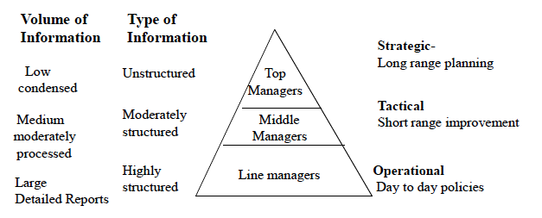
MANAGEMENT STRUCTURE AND THEIR INFORMATION NEEDS
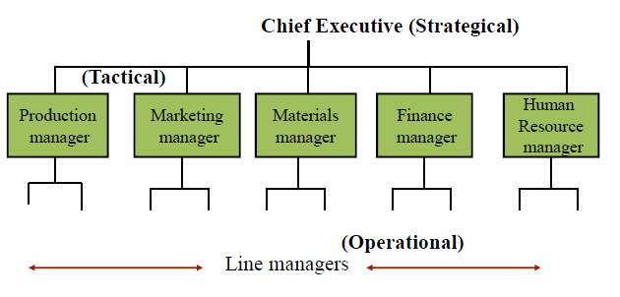
TOP MANAGEMENT
- Chief Executive known as CEO
- Executive Directors for each functional area such as Production, Finance, HRD etc.
- Take strategic decisions
MIDDLE MANAGEMENT
- General managers, divisional managers, Vice presidents etc
- Each functional area may have 2 to 3 middle level managers reporting to top management
- Take Tactical decisions
LINE MANAGERS
- Group managers, Assistant Group managers, Assistant managers
- Each functional area may have several line managers reporting to middle level managers.
- Take Operational decisions
FUNCTIONAL AREAS
- PRODUCTION
- MARKETING
- MATERIALS – purchase, stores
- FINANCE –Accounts
- HUMAN RESOURCE DEVELOPMENT(HRD)
- RESEARCH AND DEVELOPMENT (R&D)
All organizations need not have identical functional areas. However some are common such as
- MARKETING
- FINANCE
-HUMAN RESOURCE DEVELOPMENT (HRD)

Functional Area | Strategic Information | Tactical Information | Operational Information
Production Management: The goal of production management is to optimally deploy human resources, machines and materials to maximize production of goods by the organization. To attain this goal the following types of information are needed: | - Yearly and monthly production quotas and alternate schedules  - Policies on machine replacement, augmentation, and modernization.  - Information on the introduction of new production technologies, acquisition.  - Identifying best product mix.  - Policy on quality assurance | - Identifying and controlling areas of high cost.  - Identifying critical bottlenecks in production.  - Identifying alternate production schedules based on tools, machines etc.  - Performance measures of machines to decide replacement.  - Quality control measures. | - Monitoring up to date production information by examining assemblies, detecting likely shortages and giving early warning.  - Scheduling better production dynamically.  - Preventive maintenance schedules.  - Monitoring tool, machine and personnel availability.  - Ensuring quality at each step in production.
Marketing Management | - Search for new markets and marketing strategies.  - Analysis of competitor’s strategy.  - Technology and demographic forecasts and product changes. | - Advertising techniques and analysis of their impact.  - Customer preference surveys.  - Correlation of prices and sales.  - Sales force deployment and targets.  - Exploring alternate marketing channels.  - Timing of special sales campaigns. | - Sales analysis by regions, customer class, sales person.  - Sales target versus achievement.  - Market share and trends.  - Seasonal variations.  - Effect of model changes.  - Performance of sales outlets  - Costs of campaigns and benefit.
Material Management  The goal of materials management (often called as supply chain management) is to have readily available materials needed by the organization and to keep optimal levels of stock of items. To attain this goal the following types of information are needed: | - Developing vendors for critical items.  - Determining optimal levels of inventory  - Determining proportion of material needed  - Reducing varieties of inventory. | - Developing vendor performance measures.  - Determining optimal reorder levels.  - Determining issues of items to shops versus standard needs.  - Controlling high value of inventory.  - Determining impact on material cost and procurement with design changes and new product introduction. | - List of excess & deficient items received.  - List of items rejected.  - Critical items received.  - Stores in transit and in inspection.  - Value of inventory in hand.  - Goods received, rejected and issued
Finance Management | - Methods of financing.  - Pricing policies.  - Tax planning. | - Variations between budget and expenses.  - Large outstanding payments/Receipts.  - Credit and payment status.  - Cost increases and pricing.  - Impact of taxation on pricing | - Periodic financial report.  - Budget status to all functional managers.  - Tax returns.  - Share transfers.  - Profit and loss account.  - Payments and receipts.  - Payroll, provident fund accounts.
HR Management:  The major goal of HR management is to make best use of the available human resources in the organization. To attain this goal, the information necessary at various levels of management is : | - Long range human resource requirements at different levels.  - Policies on human resource development and training  - Policies on personnel welfare and facilities | - Performance appraisal.  - Demographic make-up of personnel and its impact on retirement.  - Production incentives.  - Morale of personnel.  - Absentee reduction.  - Leave and overtime policies.  - Personnel deployment policies. | - Routine assessment.  - Skills inventory.  - Loan/advances and recoveries.  - Leave record.  - Overtime assignment.
Research Design and Development Management | - Which products are to be developed?  - What types of improvements are required?  - What long range research is more promising?  - What technical collaboration would be appropriate? | - Setting intermediate goals.  - Checking availability of equipment & appropriate selection  - Determining proportions of resources to be allocated to different projects.  - Deployment of personnel to projects.  - Information on similar and related research projects undertaken by other companies | - Progress against goals.  - Budgeted expenses versus actual expenses.  Status of outstanding orders for equipment and components.

Design of an Operational Information System
- Creation of initial database by an external data entry agency
- Editing and storing the database on an on-line hard disk
- Processing customer request
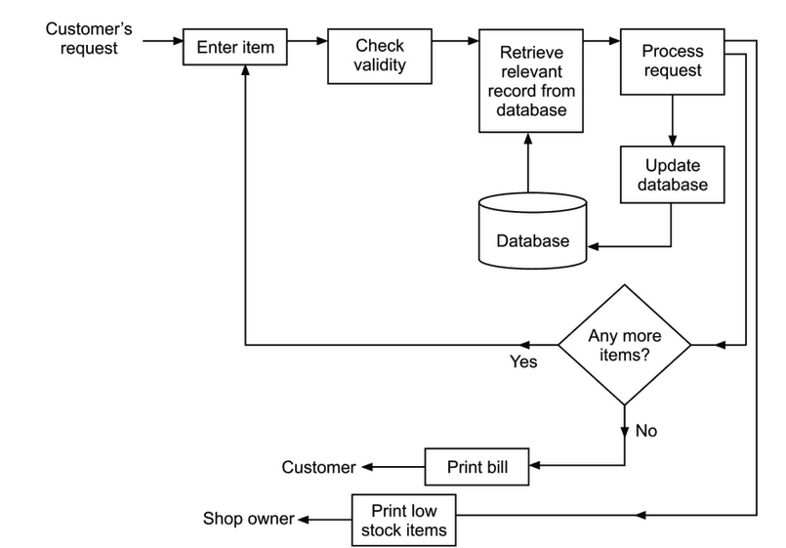
Fig. : Information system of a medical shop.
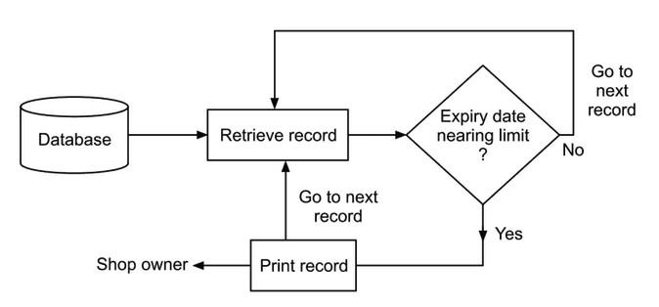

Fig. : Finding medicines nearing expiry date.

System Life Cycle
After the system has been in operation for a reasonable period, it is evaluated and a plan for its improvement is drawn up. The below figure summarize the information analysis and design procedure. This is called system life cycle. The shortcomings of a system – namely, what a user expected from the system and what he actually got are realized only after a system for a reasonable time.
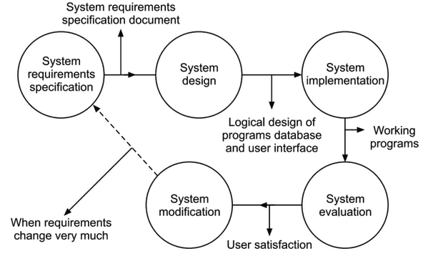
Fig. : Stages in a system’s Life Cycle.
Phase | What is Done During this phase? | Output of this phase
- System Requirements specification (SRS) | Determine requirements to be met by system being contemplated. Prioritize requirements. Obtain functional specifications of the final requirements. | System requirement specification document. System test plan
- System design | Logical design of programs for the given hardware. Design of databases, user interface, test plan. | Program specifications. Database design. User interface documents.
- System implementation | Writing programs, creating databases, user interface implementations. Install programs. Test with live data. Train users and maintenance staff | Programs, databases, user manual, program manual, maintenance manual
- System evaluation | Determine user satisfaction. Examine change requests. | Evaluation report with suggestion for improvement.
- System modification / maintenance | Add, delete features. Implement modified needs within bounds. | Improves system to meet current needs.
Computer System for Transaction Processing
Earliest transaction processing systems used a centralized large mainframe computer connected to a number of dumb terminals (did not process any data, just used to enter transactions and display results). This is called client-server computing.
Advantages:
- Ease of server maintenance
- Better security
Disadvantages:
- Expensive
- Centralization
With the advent of low cost powerful PCs, all the computers are connected to a LAN. The data can be in a centralized server or in several computers if it is a distributed system. There are two approaches to protect the data and restore them if lost accidentally.
- Backup (periodic)
- Redundancy and duplicate every transaction. (This is very expensive).
Archiving is done to accumulate historical data. The archived data can be used to analyze trends for long range tactical decision making. This is called data mining.

IV Social Impact of Information Technology

Refer Assignment - 1

V Browser fundamentals
Browsers
- A web browser is a software application for retrieving, presenting and traversing information resources on the World Wide Web.
- An information resource is identified by a Uniform Resource Identifier (URI/URL) that may be a web page, image, video or other piece of content.
- Hyperlinks present in resources enable users easily to navigate their browsers to related resources.
Some of the popular web browsers
- Google Chrome.
- Firefox.
- Safari.
- UC.
- Iron.
- Internet Explorer.
- Opera.
- Android.

Browser Architecture
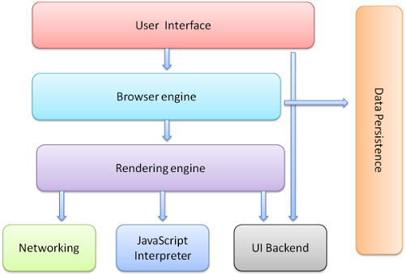
Fig.: Main components of the browser
- User Interface: The user interface is the space where User interacts with the browser. It includes the address bar, back and next buttons, home button, refresh and stop, bookmark option, etc. Every other part, except the window where requested web page is displayed, comes under it.
- Browser engine The browser engine works as a bridge between the User interface and the rendering engine. It provides a high-level interface to the rendering engine. The browser engine provides methods to initiate the loading of a URL and other high-level browsing actions (reload, back, forward). According to the inputs from various user interfaces, it queries and manipulates the rendering engine. The browser engine also provides the User interface with various messages relating to error messages and loading progress.
- Rendering engine: produces the visual representation of a given URL. The Rendering Engine interprets the HTML, XML, and JavaScript that comprises a given URL and generates the layout that is displayed in the User Interface. A key component of the Rendering Engine is the HTML parser, this HTML parser is quite complex because it allows the Rendering Engine to display poorly formed HTML pages. Different browsers use different rendering engines: Internet Explorer uses Trident, Firefox uses Gecko, Safari uses WebKit. Chrome and Opera uses WebKit (before is Blink)
- Networking: Component of the browser which retrieves the URLs using the common Internet protocols of HTTP and FTP. The Networking components handle all aspects of Internet communication and security, character set translations and MIME type resolution. The Network component may implement a cache of retrieved documents to minimize network traffic.
- JavaScript Interpreter It is the component of the browser which interprets and executes the JavaScript code embedded in a website. The interpreted results are sent to the rendering engine for display. If the script is external then first the resource is fetched from the network. Parser keeps on hold until the script is executed.
- UI Backend: UI backend is used for drawing basic widgets like combo boxes and windows. This backend exposes a generic interface that is not platform specific. It underneath uses operating system user interface methods.
- Data persistence: This is a persistence layer. Browsers support storage mechanisms such as localStorage, IndexedDB, WebSQL and FileSystem. It is a small database created on the local drive of the computer where the browser is installed. It manages user data such as cache, cookies, bookmarks and preferences.

VI Authoring Tools
Authoring tools are software used for designing and presenting webpage’s. Web authoring tools are based on HTML scripts and also use Java language to enhance the look and feel of a webpage. Web authoring tools are used to create Web content, and cover a wide range of software programs you can download to your computer or access online.
The distinction between authoring tools and programming tools is not clear-cut. Typically, though, authoring tools require less technical knowledge to master and are used exclusively for applications that present a mixture of textual, graphical, and audio data.
Some popular web authoring tools
- Microsoft frontpage
- Dreamweaver
- HTML Kit
- Komodo Edit
- KompoZer
- Advanced Image Editor

Features /Advantages of web authoring tools
- It is an Integrated development environment (IDE)
- Fast and easy way for developing web sites
- Automatic generation of web contents based on templates,design etc.,
- The end user can see a visual result even before the web page is completely deployed
- They are based on What You See is What You Get(WYSWYG)
- Easy to develop web page (Even without knowing the complete syntax of HTML)
- Easy to use GUI
- Drag and drop features
- Reuse of graphics and texts across the sites
- Supports dynamic html and scripts

VII Types of Servers
A server is a computer program that provides services to other programs or devices, called "clients". This architecture is called the client–server model. Servers can provide various functionalities, such as sharing data or resources , performing computation for a client. A single server can serve multiple clients.
Types of Servers
- Application server
- Web server
- Database server
- File server
- Print server
- Proxy server

VIII Application Server
Definition
An application server is a computer that provides a platform to run a server program in a network. An application server also provides a platform for running business logic that is accessible by client programs. An application server is a part of three – tier architecture. Three tier architecture consists of
- Graphical user interface (Front End) server
- Application (Business Logic ) server
- Database (back End) server
An application server is an interface between the front end and back end servers. In many situations the application server also performs the job of the front end server, in such case the application server is called as Web Application Server.
Components of Application Server
An Application server consists of the following components
- Server components
- Programming Languages
- Run time libraries
- Database components
- Administrative tools
Server Components provides system level services in a well-defined, open, industry standard manner.
Programming languages like Java, Python, and PHP assists the programmers to develop effective server programs
Run time libraries helps the programmer to develop code easily, they offer variety of library functions that helps the programmer to develop a sophisticated program
Database components are used to connect the front end web application with the back end database like Oracle, MYSQL etc.,
The administrative tools are very essential for creation, deployment and managing web applications.
Examples of Application Servers
- Microsoft Internet Information Server (IIS)
- Java Application Server (J2EE)
- Java Messaging Server (JMS)
The choice of choosing application server depends on the following factors
- cost
- performance
- reliability
- scalability
- security
- availability
- maintainability
- Software and Hardware environment.

IX Web Server
Definition
An application server refers to a computer or a program that accepts the request from the client usually a web browser, process the request in the server and send the response to the client. A web server uses HTTP (Hyper Text Transfer Protocol) for accepting the request and providing the response.
The response message from the web server will usually comprise of HTML page, Images, Cascading Style Sheets (CSS)
Working of Web servers
Web Client
Web Server
Request for Web Pages
Web Server provides Pages

When the user requests for a web page present in the internet using a web browser, the browser request the web server to transfer the specified web page. For example when the user type the URL http://www.google.com, in the browser , the browser request for the google.com web page from the web server. The web server transfers the specified web page to the user. If the requested page isn't found, the web server sends the appropriate error code/message back to the user. The following steps are involved in the web client and web server communication
- The Web client (usually the web browser) requests for the web page
- The web browser resolves the domain name (Eg. www.google.com) to the corresponding IP Address ( Eg. 192.168.10.1), to do this the web browser may request information from few Domain Name System (DNS) servers via internet.
- The web server will transfer the requested web page
- The web browser finally displays the web page.
The choice of choosing application server depends on the following factors
- Operating Server used in the server
- Nature of the server side programming
- Security characteristics
- Performance
Examples of Web server
- Apache web server
- Microsoft Internet Information Server (IIS)
- Google web server (GWS)
- IBMs Domino Servers

X Database Server
Definition
Database server refers to a back end system that runs a database using both software application and hardware components. Database server is the key component in the traditional client server architecture. Usually the database server is a dedicated powerful system that stores the database. Database server can store data in the database in a various forms that include relational structure and flat file structure.
Applications that run on the front end application servers depend on database servers for all their data needs to perform computation. Database servers are capable storing huge volume of both structured and unstructured data. The database server is capable of performing the following tasks
- Data storage
- Data analysis
- Data manipulation
- Data archiving
Database Server Architecture
There are two forms of database server architecture. They are
- Two tier client-server architecture
- Three-tier client-server architecture

Two tier client-server architecture
In this type of architecture the first tier (called as the client) runs the user interface as well as application programs. These client programs use an interface called Open Database Connectivity (ODBC) drivers. These drivers help the client program to establish a connection with the back end database server.

Client 1
Client 2
Client ‘n’
Database Server
Other servers
File Server

Three-tier client-server architecture
Three tier client server architecture is used for developing web based applications. In this type of architecture the first tier (Client tier) displays the graphical user interface for the end users, through which the end users interact with the application
The second tier i.e. the middle tier is also called as Application tier. This application tier runs the program called business logic that determines the behavior of the application. The third tier holds the database server that is capable of storing data. The database server is also responsible for providing data to application, whenever the program request for data access.

Examples of Database Server
- Oracle
- Microsoft SQL server
- DB2
- MySQL
- Informix

